**PROJECT REPORT**

**Android Application**

**IIIT Allahabad**

**Course-**

Operating Systems

**Course Instructor-**

Mr Muneendra Ojha

**Submitted by**-:

Group no- 30

Yash Sharma (IHM2014006)

Shubham Swarnkar (IWM2014001)

Vishal Chauhan (ITM2014007)

**Contents**

1. Acknowledgement
2. Introduction
3. Motivation
4. Procedure.
5. Working & Formula
6. Problems we faced.
7. Solutions.
8. Conclusion.

***Acknowledgements***

We have taken efforts in this project. We would like to extend my sincere thanks to anyone who has helped us in completing the project.

We are highly indebted to Mr Muneendra Ojha for his guidance and constant supervision as well as for providing necessary information regarding the project & also for their support in completing the project.

We would like to express our gratitude towards sir for his kind co-operation and encouragement which help us in completion of this project.

Our thanks and appreciations also go to our colleague in developing the project and people who have willingly helped us out with their abilities.

***Introduction***

An *odometer* is an instrument that calculates the distance traveled by a vehicle or a person when they move from one place to another.

Our project is an Android Application which not only tells the distance travelled by a person during jogging but also the calories burnt.

***Motivation***

*In today’s fast paced world, jogging is the most popular exercise for fitness* conscious people.

*Wouldn’t it be great to know the total calories we just burnt right after we finish our jogging!*

*Not only will it helps us manage our diet but will also keep us motivated.*

*So we developed an App that fulfils exactly the same purpose.*

***Odometer App Walkthrough***

1. *Tap the app’s icon to launch the application.  
     
   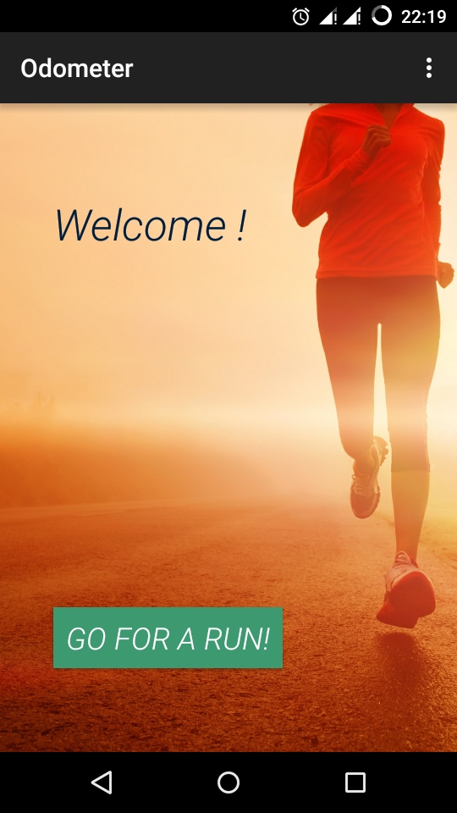*
2. *On the first run, you will be asked to enter some information.*
3. *Tap on “Yes” then you will be asked to enter your details such as username and your weight in kilograms in a newly opened “Settings” window.*
4. *Now tap save to save your details and you will be directed back to home screen.*
5. *To start press “Go for a new run” button.  
   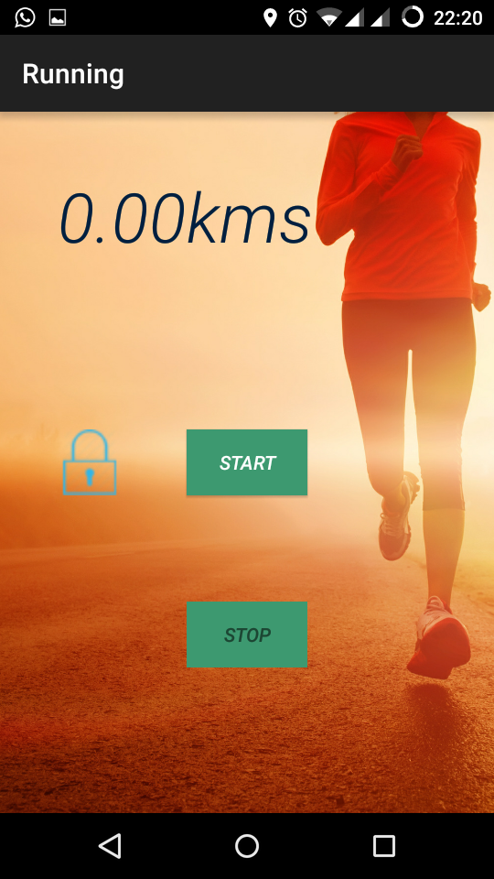*
6. *Running window will now be opened.*
7. *As you start running, distance displayed will start increasing.*
8. *When you are done, unlock the buttons by tapping on the lock and buttons will get unlocked.*
9. *This lock functionality is added to prevent accidental clicks.*
10. *After this a new window will appear which will display the total distance travelled and also the total calories burnt.  
    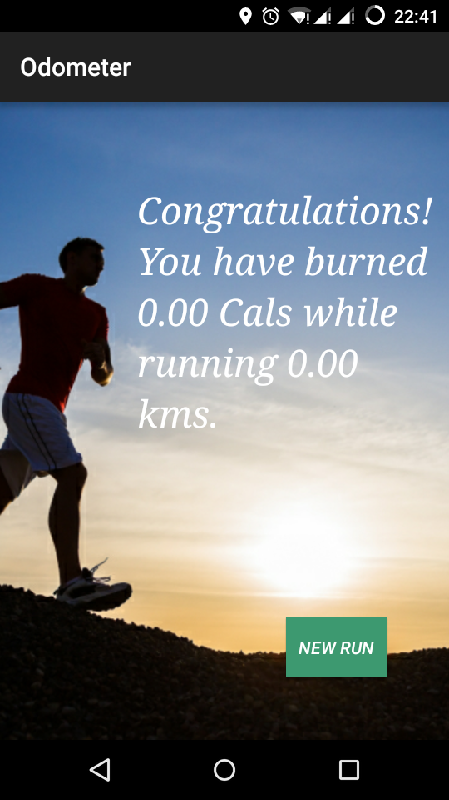*
11. *If you want to start running again, press new run button.*
12. *Also on the home page, if you want to enter settings, open context menu from top right corner of the screen and tap on settings.  
      
    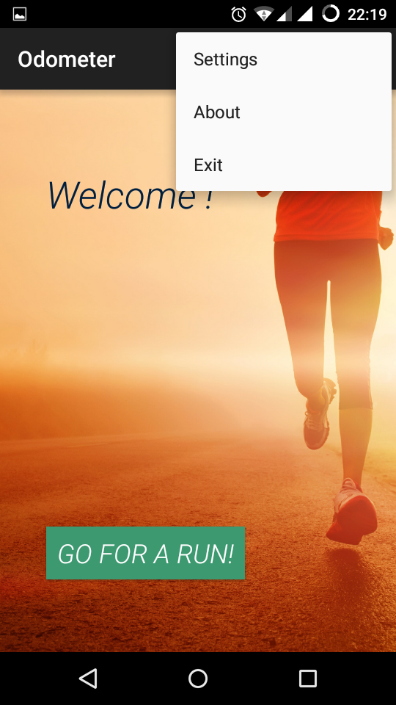*

**Working -**

The application runs a background service called OdometerService which binds itself to Odomeasure Activity. By specifying in the Android Manifest file, we can use GPS or the Location Service of the Device. Using Android Location Manager and predefine methods we can access location of the Android device.

The OdometerService fetches the location of the device and stores it in lastLocation variable. After each second, the new location is updated and distance from the previous location is calculated and is added to the total distance.

At the end of the run, a formula is used to calculate the total calories burnt.

**Formula Used-**

Total calories burnt = 0.75 * BodyWeight (in lbs.) * distance covered (in miles).

**Problems we faced-**

1. The biggest problem that we faced was providing the permission for GPS.
2. The other major problem was to include database in our app for storing details of user.
3. When the result of a run comes we gave a ”new run” button for new run But the problem was after pressing “new run“ the new distance start adding in the previous distance calculated.

**Solutions-**

1.) For GPS permission we added this permission to Android Manifest File.

“**android.permission.ACCESS_FINE_LOCATION.**”

2.) For storing details we used **shared preferences** instead of database.

3.) We reset the distance covered during previous run through some changes in code.

**Conclusion-**

We expect our application to be useful for anyone who wishes to estimate calories burnt and distance covered at the time of jogging. Also to keep all people motivated throughout the journey of achieving a physically fit body.